**UNIT – I**

**Concept of Electric Circuits**: Introduction to circuit elements, V-I relationships of R, L and C elements, Ideal and Practical Sources, Kirchhoff’s laws, Source Transformation, Network reduction techniques-series, parallel, series-parallel and Star-Delta transformation.

**What is an electrical circuit?**

An **electric circuit** is a path in which electrons from a voltage or current source flow. The point where those electrons enter an **electrical circuit** is called the "source" of electrons.

**What do you mean by electrical network?**

An **electrical network** is an interconnection of **electrical** components (e.g. batteries, resistors, inductors, capacitors, switches) or a model of such an interconnection, consisting of **electrical** elements (e.g. voltage sources, current sources, resistances, inductances, capacitances).

**How do electrons flow around a circuit?**

**Current** only **flows** when a **circuit** is complete—when there are no gaps in it. In a complete **circuit**, the electrons **flow** from the negative terminal (connection) on the power source, through the connecting wires and components, such as bulbs, and back to the positive terminal.

**Current:**

An electric current is a flow of electric charge (electrons).

Unit of Electric current is **Ampere**

Electric current is measured using a device called an **ammeter.**

**Voltage:**

Voltage is the electromotive force or the electrical potential (Charge) difference between two points in a circuit.

Unit of Voltage is **volt**

Voltage is measured using a device called **voltmeter.**

**Types of network Elements**:

The circuit elements are classified into following categories,

1. Passive and active elements.
2. Unilateral and Bilateral elements.
3. Linear and Non-Linear elements.

**Passive and Active Elements**

**Passive Element**: The elements that absorbs or stores energy is called passiveelement.

` Examples: Resistor (R), Capacitor (C), Inductor (L), Transformer

**Active Element**: The elements that supply energy to the circuit is called activeelement.

Examples: Voltage and Current sources, Generators, Transistor.

**Unilateral and Bilateral Element**

**Bilateral Element**: Conduction of current in both directions in an element withsame magnitude is termed as bilateral element.

Examples: Resistance; Inductance; Capacitance

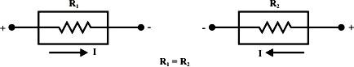

**Unilateral Element**: Conduction of current in one direction in an element istermed as unilateral element

Examples: Diode, Transistor.

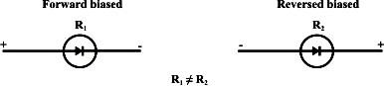

**Linear and Non Linear Elements**

**Linear Element**: The elements that obeys ohm’s law and homogeneityprinciple is called linear element.

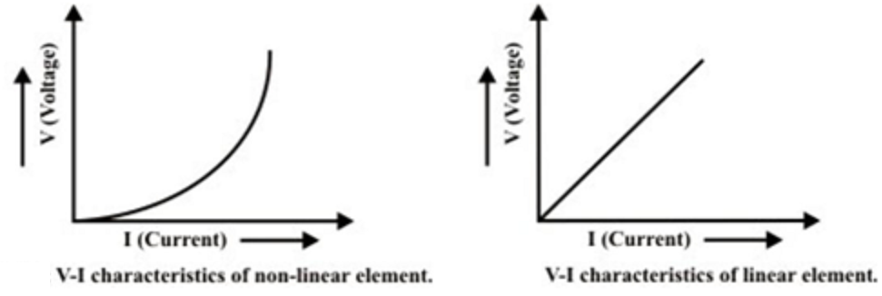Examples: Resistor (R), Capacitor (C), Inductor (L)

**Non-Linear Element**:The elements that does not obey ohm‟s law andhomogeneity principle is called Non-Linear element.

Examples: Semiconductors, Diode, Transistor

**Types of Sources**:

**Independent Sources**:

Independent sources are those in which generated voltage (VS) or the generated current (IS) are not affected by the load connected across the source terminals or across any other element that exists elsewhere in the circuit or external to the source.

Ideal and Practical Voltage Sources:

* An ideal voltage source, which is represented by a model in below fig, is a device that produces a constant voltage across its terminals no matter what current is drawn from it (terminal voltage is independent of load (resistance) connected across the terminals)
* The V- I characteristic of ideal voltage source is a straight line parallel to the x-axis.

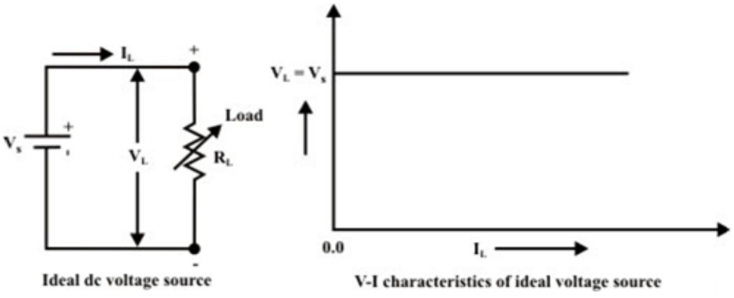

* Internal resistance (RS) of a ideal voltage source is zero.

RS = 0

* A practical voltage source, which is represented by a model in below fig, is a device that does not produces a constant voltage.
* The V- I characteristic of a practical voltage source can be described by the following equation

VL = VS – IRS

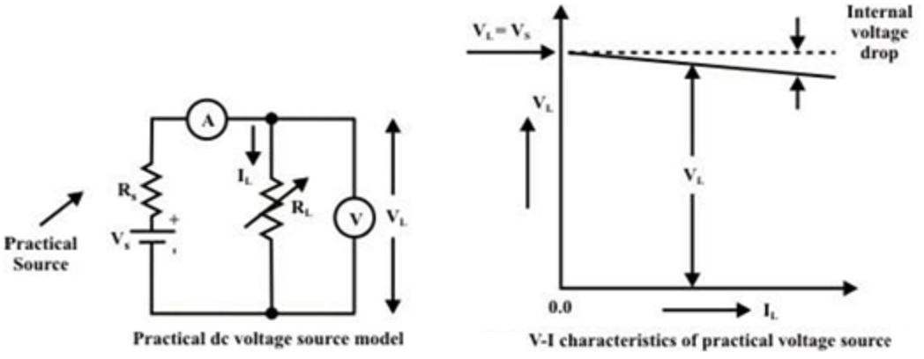

**Ideal and Practical Current Sources**:

* An ideal current source, which is represented by a model in fig is a device that delivers a constant current to any load resistance connected across it, no matter what the terminal voltage is developed across the load (i.e., independent of the voltage across its terminals across the terminals).
* The V- I characteristic of ideal current source is a straight line parallel to the y-axis.

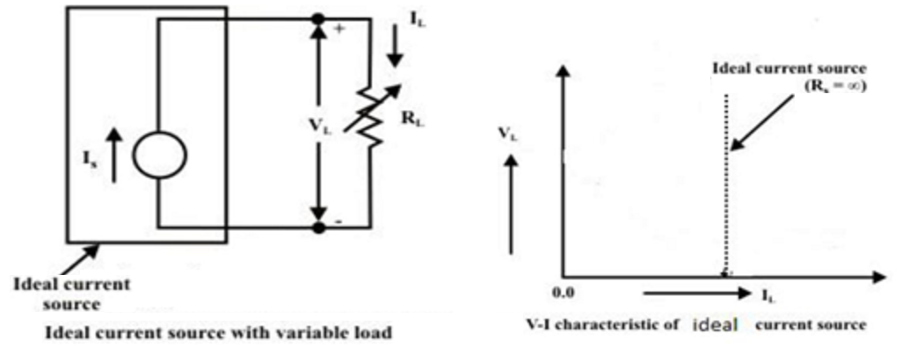

* Internal resistance (RS) of a ideal Current source is Infinity.

RS = ∞

* A practical voltage source, which is represented by a model in below fig, is a device that does not produces a constant current.
* The V- I characteristic of a practical current source can be described by the following equation

IL = IS − VL

RS

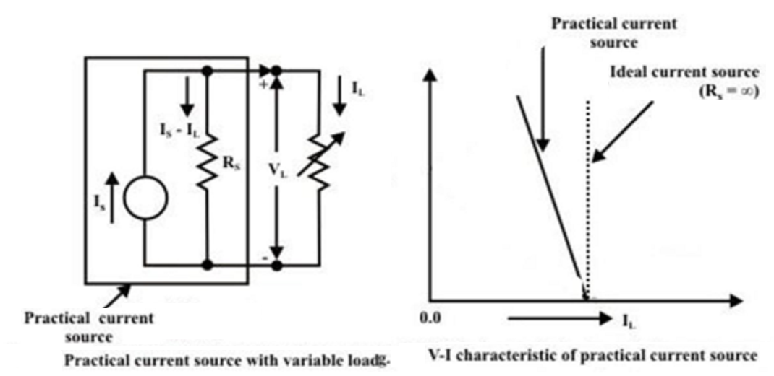

**DEPENDENT OR CONTROLLED SOURCES:**

In some network, in which some of the voltage sources or current sources are controlled by changing of current or voltage elsewhere in the circuit. Such sources are termed as “Dependent or Controlled sources”.

There are four types of dependent sources.

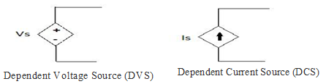

* CDVS( Current DVS)
* CDCS(Current DCS)
* VDVS(Voltage DVS)
* VDCS(Voltage DCS)

**Resistor:**

**Resistance (R):** The opposition offered to the flow of electric current flowing through the material is called Resistance.

Unit: Ohm(Ω)

**Laws of Resistance:**

Electrical resistance (R) of a conductor is

1. directly proportional to its length, l i.e. R ∝ l,
2. inversely proportional to its area of cross-section, a i.e.

http://www.electrical4u.com/wp-content/uploads/2013/03/resistivity0.gif

Combining these two laws we get,

http://www.electrical4u.com/wp-content/uploads/2013/03/resistivity1.gif

Where ρ is a constant depending on the nature of the material of the conductor and is known as it’s Specific Resistance or Resistivity.

**Specific Resistance or Resistivity:**

**Specific Resistance or Resistivity** is the resistance of a material with unit length and unit cross sectional area.  
**Unit:**

The **unit of resistivity** can be easily determined form its equation

http://www.electrical4u.com/wp-content/uploads/2013/03/resistivity2.gif

**Conductance:**

 It is the inverse of resistance. $G= \frac{1}{R}$

**Unit:**

$G= \frac{1}{Ω}=mho$ (or) siemen

**Conductivity:**

 It is the inverse of resistivity. $σ= \frac{1}{ρ}$

**Unit:**

$σ= \frac{1}{Ω-m}=mho/m$ (or) Siemen/m

**Factors affecting the Resistance:**

**1. Length of the material:**

The Resistance “R” is directly proportional with its length: **“L”**

**R ∝ l**

As length of the wire increases, resistance also increases.

**2. Cross Sectional Area of the material:**

The Resistance “R” is inversely proportional with its Cross Sectional Area: **“A”**

**http://www.electrical4u.com/wp-content/uploads/2013/03/resistivity0.gif**

As Cross Sectional Area of the wire increases, resistance also decreases.

**3. Nature of the material:**

The Resistance “R” is dependent on the Nature of the material.

* In Conductors, No of free electrons are very high so resistance of the conductor is very less.
* In Insulators and Semi conductors, No of free electrons are less so resistance of the conductor is very high.

**4. Temperature of the conductor:**

The Resistance “R” is dependent on the Temperature of the conductor.

**R2 = R1 (1 + α*ΔT)**

Where ‘α’ is the temperature coefficient of resistance

* For Conductors **‘α’ = +ve, as** temperature increases, resistance also increases.
* For Insulators and Semi conductors **‘α’ = -ve, as** temperature increases, resistance decreases.

**Ohm’s law:**

***At a constant temperature the voltage across a conducting material is directly proportional to the current flowing through it.***

According to definition



$V ∝I$

$V=IR$

Where, V = Voltage across the conductor in volts

I = Current flowing through the conductor in Ampere

R = Proportionality constant (resistance in ohms)

**I-V Characteristics of Resister**

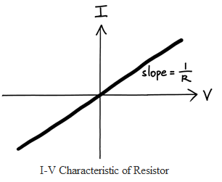

Power consumed by Resister, P=VI=V2/R=I2R

Energy consumed by Resister, W=VIt = V2t/R=I2Rt

## Inductor

The property of the coil of inducing emf due to the changing flux linked with it is known as **inductance of the coil**. Due to this property all electrical coil can be referred as **inductor**.

In other way, an inductor can be defined as an energy storage device which stores energy in form of magnetic field.

Whenever a time-changing current is passed through a coil or wire, the voltage across it is proportional to the rate of change of current through the coil. This proportional relationship may be expressed by the equation is

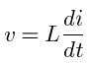

Where L is the constant of proportionality known as inductance and is measured in Henrys (H).

Remember v and i are both functions of time.

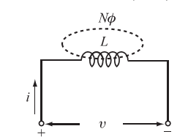

Figure 1.6 Model of the inductor

Let us assume that the coil shown in Fig. 1.6 has N turns and the core material has a high permeability so that the magnetic flux Фis connected within the area A. The changing flux creates an induced voltage in each turn equal to the derivative of the flux Ф, so the total voltage v across N turns is

 ------🡪 1

Since the total flux NФis proportional to current in the coil,

We have NФ = Li -------🡪 2

Where L is the constant of proportionality. Substituting equation (2) into equation (1), we get



The power in an inductor is



The energy stored in the inductor is

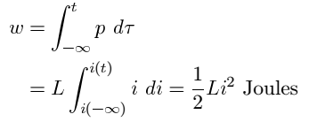

Note that when  Also note that w(t)>=0 for all i(t), so the inductor is a passive element. The inductor does not generate energy, but only stores energy.

**Capacitor**

A capacitor is a two-terminal element that is a model of a device consisting of two conducting plates separated by a dielectric material. Capacitance is a measure of the ability of a device to store energy in the form of an electric field.

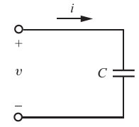

1.7 Circuit symbol for a capacitor

Capacitance is defined as the ratio of the charge stored to the voltage difference between the two conducting plates or wires



The current through the capacitor is given by



The energy stored in a capacitor is

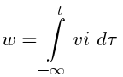

Remember that v and i are both functions of time and could be written as v(t) and i(t).

Since



We have

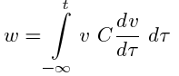

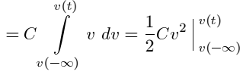

Since the capacitor was uncharged at 

Hence

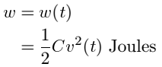

Since q =Cv we may write



Note that since w(t) >= 0 for all values of v(t), the element is said to be a passive element.

**Kirchhoff Laws:**

Gustav Kirchhoff (1824-1887), an eminent Germen physicist did a considerable amount of work on the principle of governing behavior of electric circuits. He gave his finding in a set of two laws which together called Kirchhoff’s laws. These two laws are

1. Kirchhoff’s Current Law (KCL)
2. Kirchhoff’s Voltage Law (KVL)

**Kirchhoff’s Current Law (KCL)**

***Kirchhoff’s Current Law states that the algebraic sum of the current meeting at a node (junction) is equal to zero***

i.e., ∑ I =0

This law is illustrated below. Five branches are connected to node O which carries currents I1, I2, I3, I4 and I5 as shown in figure (1). Consider current entering (I1, I3 & I5) to the node as positive and current leaving (I2 & I4) from the node as negative.



Fig. (1) Five branches are connected to node o

From above diagram

-I1- I2+ I3+ I4+ I5=0

or

I1+ I2= I3+ I4+ I5

i. e., Incoming currents = Outgoing currents

Hence Kirchhoff’s first law can be stated as:

***The currents flowing towards any junction in an electric circuit is equal to the sum of the currents flowing away from the junction***

Examples:

Find out the value of unknown current I from the given networks

Example 1



Where incoming currents are 5A and 10A, outgoing current is I. By applying KCL at node o

$$I-5-10=0$$

or

$$I=15 A$$

**Unknown current I = 15A**

Example 2



Where incoming currents are I, 10A and 5A

By applying KCL at node o

$$-I-5-10=0×$$

or

$$I=-15 A$$

**Unknown current I =** -**15A**

This minus sign indicates that the actual current direction is opposite.

**Kirchhoff’s Voltage Law (KVL)**

***The algebraic sum of the all branch voltages in a loop (or closed path) is equal to zero***

or

**Kirchhoff’s Voltage Law *states that in a closed circuit, the algebraic sum of all source voltages must be equal to the algebraic sum of all the voltage drops.***

**Steps to follow**

Step. 1. Mark all the nodes

Step. 2. Mark all branch currents

Step. 3. Mark voltage drop across each resistor (mark current entering point as positive and current leaving point as negative).

Step. 4. Depend up on the number of unknowns write KVL equations (At the time of writing equations consider the sign which see first for the voltage drops and voltage sources)

Step. 5. By solving this equations calculate the unknown branch currents and determine the desired responses.

**Illustration of Kirchhoff’s law**

Apply KVL and determine current flowing through each element.



Solution,



Step 4 – Write KVL equations

From loop – ABCDA

$$V_{1}+V_{2}+V_{3}+V_{4}-V=0………………………….(1)$$

From ohm’s law

$V_{1}=I×R_{1}, { V}_{2}=I×R_{2},{ V}_{3}=I×R_{3} \& V_{4}=I×R_{4},$ Substitute these values in to equation 1.

$$I×R_{1}, + I×R_{2}+I×R_{3}+I×R_{4}-V=0$$

$$I×{(R}_{1}, + R_{2}+R_{3}+R_{4})=V$$

$$I=\frac{V}{{(R}_{1}, + R_{2}+R_{3}+R_{4})}$$

Example.

Find out the value of unknown current I from the given networks





Step 4 – Write KVL equations

From loop – ABCDA

$$V_{1}+V_{2}+V_{3}+V_{4}-V=0………………………….(1)$$

From ohm’s law

$$V_{1}=I×100, { V}_{2}=I×50,{ V}_{3}=I×25 \& V_{4}=I×25,$$

Substitute these values in to equation 1.

$$I×100+I×50+I×25+I×25,-200=0$$

$$I×{(100+50+25+25}_{1})=200$$

$$I=\frac{200}{200}=1A$$

**Source Transformation**

• Not possible to transform ideal current (voltage) sources to ideal voltage (current) sources.

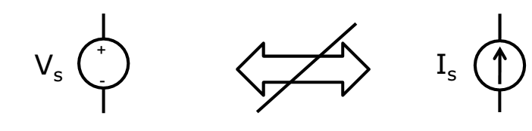

• But we can transform Practical current (voltage) sources to Practical voltage (current) sources.

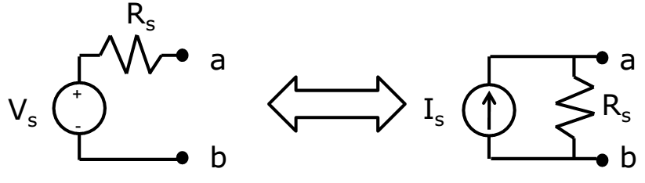

Relationships:

**IS = VS/R**

**VS = IS.R**

**Resistors in Series**

Consider the series combination of N resistors shown in Fig. 3.26a.We want to simplify the circuit with replacing the N resistors with a single resistor Req so that the remainder of the circuit, in this case only the voltage source, does not realize that any change has been made. The current, voltage, and power of the source must be the same before and after the replacement.

First, apply KVL:

**vS =v1+v2+···+vN**

and then Ohm’s law:

**vS =R1i +R2i +···+RNi =(R1+R2+···+RN)i**

Now compare this result with the simple equation applying to the equivalent circuit shown in Fig. 3.26b:

**v­S =Reqi**

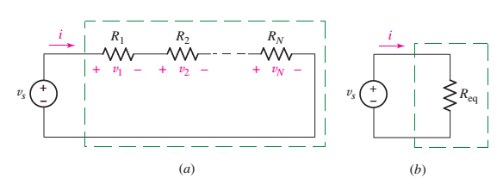

Thus, the value of the equivalent resistance for N series resistors is

**Req =R1+R2+···+RN**

**Voltage Division**

Voltage division is used to express the voltage across one of several series resistors in terms of the voltage across the combination. In Fig. 3.34, the voltage across R2 is found via KVL and Ohm’s law:

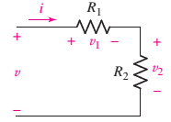**v=v1+v2=iR1+iR2=i(R1+R­2)**

So



Thus



Or



and the voltage across R1 is, similarly,



If the network of Fig. 3.34 is generalized by removing R2and replacing it with the series combination of R2, R3............RN, then we have the general result for voltage division across a string of N series resistors

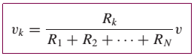

which allows us to compute the voltage **vk** that appears across an arbitrary resistor Rk of the series.

**Resistors in Parallel**

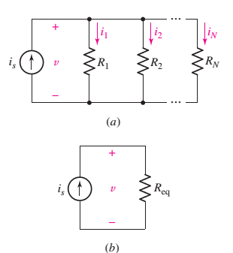Similar simplifications can be applied to parallel circuits. A circuit containing N resistors in parallel, as in Fig. 3.29a, leads to the KCL equation

**iS =i1+i2+···+iN**

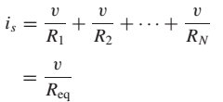

or, in terms of conductances, as

**Geq =G1+G2+···+GN**

The simplified (equivalent) circuit is shown in Fig. 3.29b.

**Current Division**

The dual of voltage division is current division. We are now given a total current supplied to several parallel resistors, as shown in the circuit of Fig. 3.37.

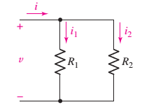The current flowing through R2 is



Or

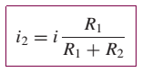

and, similarly,

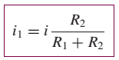

For a parallel combination of N resistors, the current through resistor Rk is

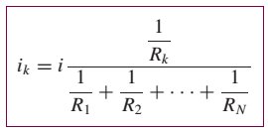

**Delta-Star(Wye) Conversion**

Star connection and delta connection are the two different methods of connecting three basic elements which cannot be further simplified into series or parallel.

The two ways of representation can have equivalent circuits in either form.

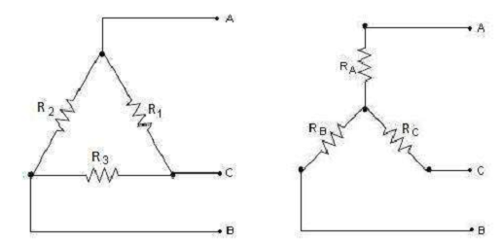

**Assume some voltage source across the terminals AB.**











**Subtracting (2) from (1) and adding to (3) ,**







**A delta connection of R1, R2, R3 can be replaced by an equivalent star connection with the values from equations (4),(5),(6).**

**Multiply (4)(5) ; (5)(6) ; (4)(6) and then adding the three we get,**

**` **

**Dividing LHS by Ra gives R3, by Rb gives R2, by Rc gives R1**





